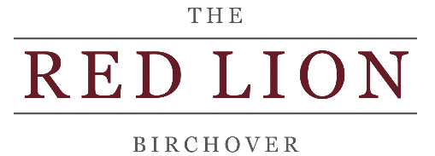
Booking terms and conditions – please read

Many thanks for choosing to book with The Red Lion Birchover.
Below are our terms and conditions for booking with us. Please take the time to read through before your visit and don’t hesitate to contact us if you have any queries relating to your booking.
- All tables booked in our dining room or ‘tap’ room will be held for 15 minutes beyond the booked time slot. If the booked party have not arrived by that point, the table will then be released for resale to other customers. If you are running late and think you might miss your booked time slot, please give us a call in plenty of time and we will try our best to accommodate a later time where possible. However, this may not always be possible at busy times or when your table is rebooked later.
- If you have reserved a table inside (we don’t reserve outside tables), we ask that you occupy the table assigned to you. You will not be permitted to move your party to an outside table as tempting as it might be if the weather is nice. If you choose to do so, we may not be able to serve you. Please bear in mind that we may have turned other customers away to save your table.
- Tables are reserved for a period of 2 hrs.
- Dogs are only allowed in the ‘tap’ room. You will have been asked on booking whether you will have a dog with you on the day of your booking. If you answered ‘no’ and then have a dog with you on the day, we may not be able to accommodate your table. Please check with your other guests that they do not intend to bring a dog.
- If you are booked into our ‘tap’ room with a dog, we ask that you keep them off the seats and on a lead.
- For tables of 6 or more we ask for £5 per person deposit which is non-refundable on cancellation, but will be taken off the total bill at the end of your meal. We don’t like doing this, but with increasing numbers of ‘no shows’, it is a policy we have had to implement to prevent losses.
- Please make us aware of any special dietary requirements/allergies/intolerances in advance of your visit. We will endeavour to cater for special dietary requirements where possible.

We sincerely hope you enjoy your visit to The Red Lion and if you have any questions, please give us a call on 01629 650363.

